Allure reports – It is a summary report of every file that you’ve tested.

Here’s an example of my Allure test reports

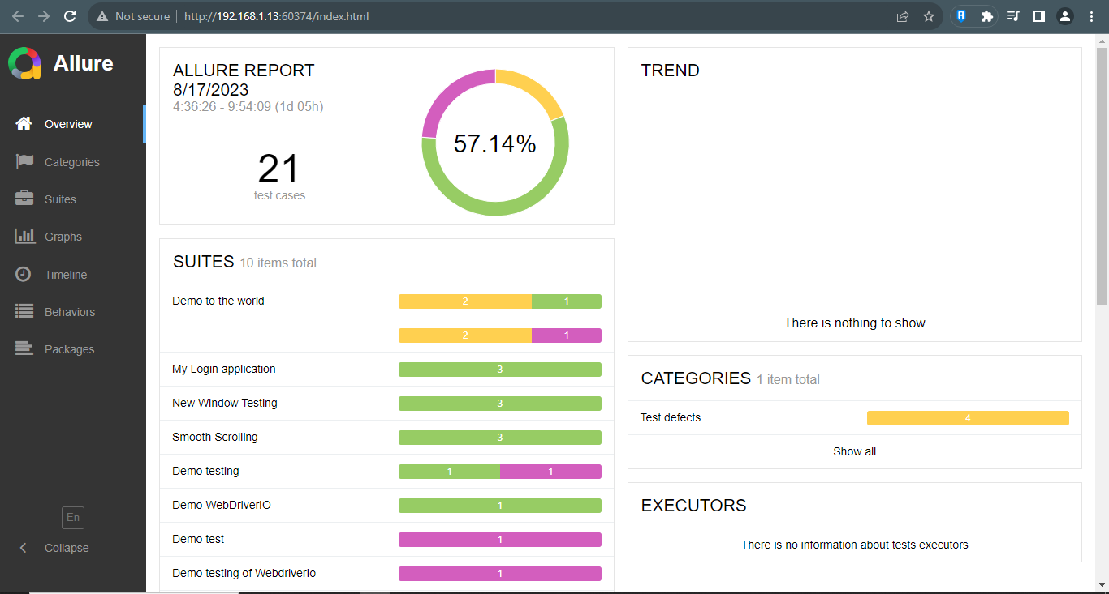

As you can see it was a very well documented report of test.

You can also see the percentage or how many test file that you’ve passed or failed in the given graph using allure reports.  
  
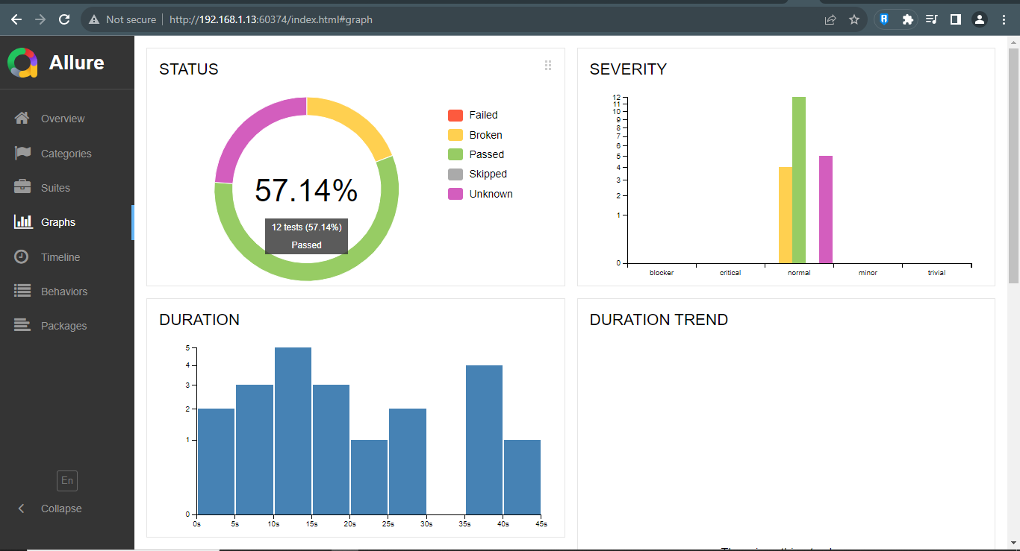

As you can see in the right side, there is an screenshot where you can see or learn where does the testing encounter an error. Because you will only get a screenshot if you encounter or detect an error and that’s make you system failed.

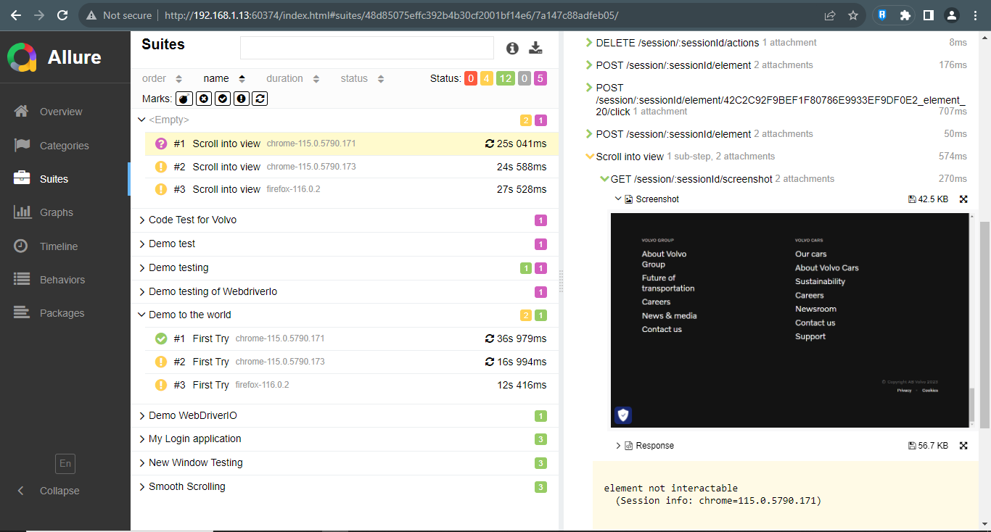

So how to put or make the screenshot when encountering error.

Go to the wdio.conf.js , put an error inside of an if statement in the aftertest.

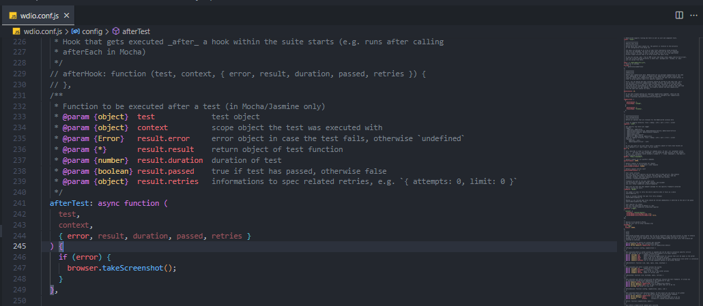

But make sure that you’ve already installed or have a allure in the reporters. So you can access the allure-reports. This is also how allure reports works.

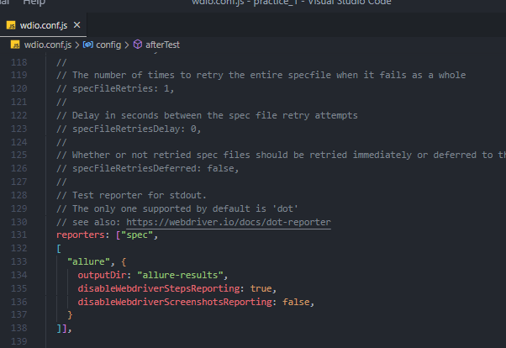

First you must test some files by running the **npm wdio run .\wdio.conf.js**   
It means it will run all your js file in the project   
then once you’re done on running and you encounter an error in the terminal or console.   
Type **allure generate .\allure-reports\** you will get this allure-results file in the left side.

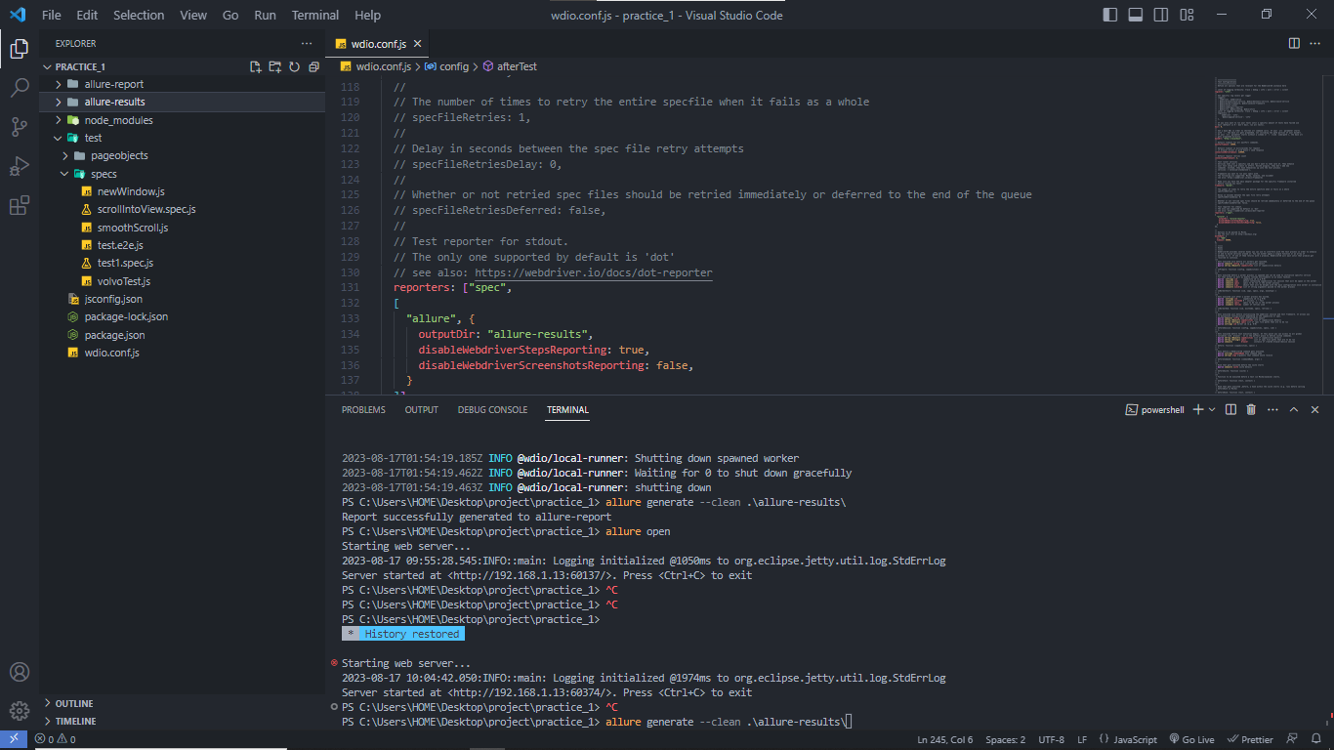

Then type allure open so it will open the allure in the browser automatically.  
It looks like this  
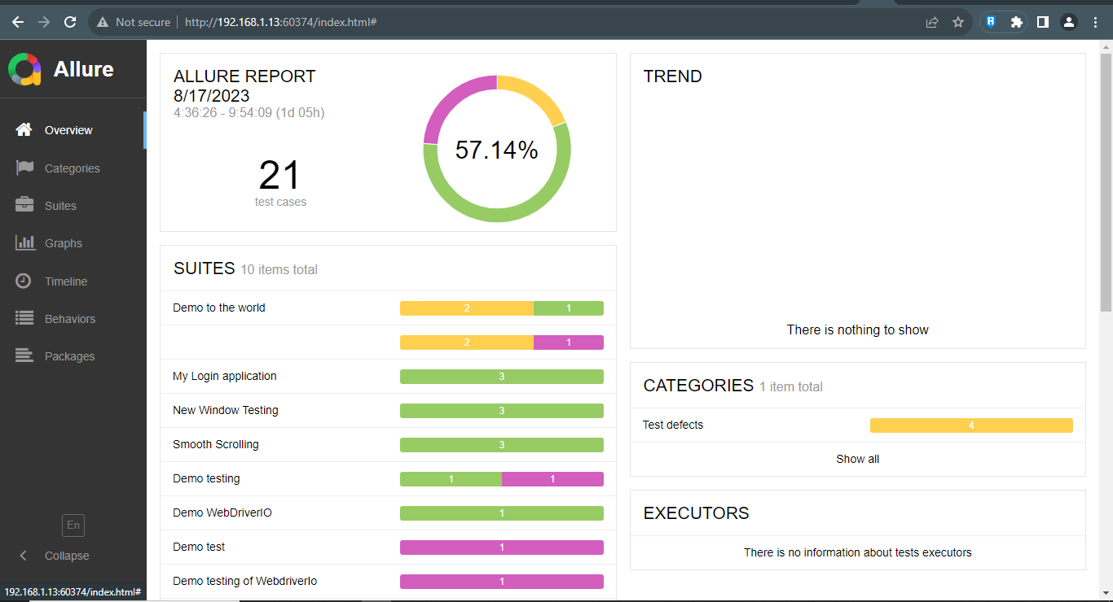  
  
Then for sure you will run it again to re test the project and get an update report. So what you’ll do is type **npm wdio run .\wdio.conf.js** to run the project and then type **allure generate --clean .\allure-reports\**   
add –clean in the middle so it will overwrite your old allure-result file and changed it to an updated result.